

September 22, 2010


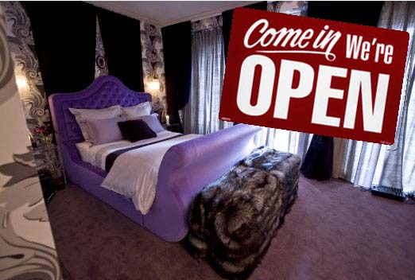
The urban exploration smorgasbord known as Open House New York returns on October 9 and 10, and we're noticing a programming trend that will especially interest the Curbed crowd. In years past, a handful of residences have opened their doors as part of the festivities. Mostly they've been private homes owned by architects and designers looking to show off their work, but occasionally a bigger real estate project sneaks in. This year, however, there are several high-profile developments opening their doors. Developers and brokers are seeking out new ways to reach potential buyers, even if it means letting the hoi polloi scuff the white-oak floors. The full OHNY schedule will be unveiled on September 28, but a press release teases a few tempting locations.

First up, as if the picture up top didn't give it away, is the boutique Flatiron condo building 16W21, with its crazy Zac Posen-designed interiors. Also on tap: The conversion-undergroing 36 Gramercy Park, Battery Park City's The Visionaire and the I.M. Pei-connected Centurion in Midtown. We expect more to hear about more real-estate-themed open houses when the OHNY schedule gets released.
As for sites that have nothing to do with price-per-square-foot, here are some early notables: the Bank of America Tower, Roosevelt Island's under-construction Four Freedoms Park, a hardhat tour of 1 World Trade Center(!), The Meatpacking District studio/oculus of Diane von Furstenberg(!!) and the still-under-wraps High Line Phase II(!!!). Sorry, we just had to geek-out for a moment.
· Open House New York [ohny.org]

