

September 24, 2010

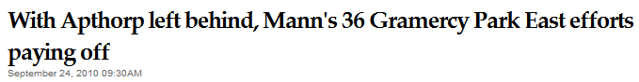
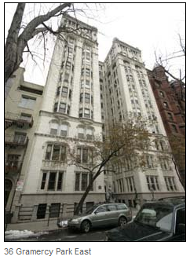
Developer Maurice Mann's latest condominium conversion, at 36 Gramercy Park East, is shaping up to be a more popular version of his efforts at the Upper West Side's Apthorp, where he stepped down as manager last year amid a bitter feud with partner Africa Israel Investments and mounting controversy about the building's offering plan. The 13-story building, which is ready to begin closings, is similarly historic, having been built around the same time as the Apthorp, in 1908. Like the Apthorp, where Mann still holds an ownership stake, it has also been home to its fair share of big names, like actor John Barrymore and Alfred Ringling, of Ringling Brothers Circus fame. But unlike the Apthorp, the Gothic-style icon breezed through the approval process at the Attorney General's office in just 35 days, thanks in part to 10 former tenants who wound up buying condo units at insider prices, an average of $1,818 per square foot. (Note: correction appended). Those discounted prices exceed the $1,150 per square foot that Apthorp tenants paid to buy their units, as well as those of tenants at most other recent condo conversions in the city, brokers said. In total, 13 of the building's 31 available condominiums are in contract, compared with around three dozen of the Apthorp's 163.

